

**Department of Computing and Information System**

**Mid-Term Project: Fall Semester-2023**

**Program: B.Sc. in CIS**

**Course Code: CIS 235**

**Course Title: Software Engineering**

**Submitted BY: Rayan ahmed  
ID:221-16-641**

**Task-1**

**---------------------------------------------------------------**

**Q1. Find out the SDLC model for the following with proper explanation: [8]**

**[CLO 1]**

**1. Project-1**

**2. Project-2**

**3. Project-3**

**4. Project which is made by Mr. Abdullah**

**Answer:**

1. Project-1

SDLC Model: Agile Model

Explanation:

Project-1 is like a project where things change a lot, and the client doesn't know exactly what they want at first. The Agile Model is the right choice for this situation.

Handling Frequent Changes and Unclear Client Needs: The Agile Model is like a toolbox that lets us change things easily when the plan doesn't work. It's great for when the client's ideas are not clear from the start.

Adapting on the Go: Agile lets us make changes as we go along and work closely with the client to keep them happy.

2. Project-2

SDLC Model: Iterative or Incremental Model

Explanation:

Project-2 is all about clients not being sure about what they want, and the project keeps changing. For this, we should go with an Iterative or Incremental Model

Changing Plans and Making Clients Happy: These models allow us to work on a project that keeps changing and aims to keep the clients satisfied, even if it takes a bit longer or costs a bit more.

3. Project-3

SDLC Model: Iterative or Incremental Model

Explanation:

In Project-3, the client's needs aren't clear at first, and we keep talking to them to understand better. This matches an Iterative or Incremental Model.

Regular Talks with the Client: These models are best when we need to keep talking to the client to understand what they want better. We can test and improve things step by step.

4. Project by Mr. Abdullah

SDLC Model: Waterfall Model

Explanation:

For Mr. Abdullah's project, it's like building something step by step, finishing one part before starting the next. This needs the Waterfall Model.

Step-by-Step Work: Just like building a house one room at a time. Finish one room before moving on to the next. It's organized and neat.

Testing All the Time: We check our work at each step to make sure it's all working right.

Managing Risks: The Waterfall Model helps us keep an eye on problems from the start and deal with them carefully.

**Q2. Which testing is preferable for Mr. Abdullah project? Describe your**

**opinion. [3] [CLO 5]**

**Answer:**

For Mr. Abdullah's project, which is developed step by step (like building a house one room at a time), a good way to test it is by checking each part as we finish it. This is called Sequential Testing.

Why Sequential Testing Works:

One Step at a Time: We test each part before moving on to the next, like checking a room in a house before starting the next one.

Making Sure It Works: We want to be sure that every piece works correctly before moving forward. This way, we catch any problems early.

Reducing Risks: It's like being cautious from the start. By checking each piece, we manage problems better and avoid big issues later on.

**Q3. If you are the project manager of this BJIT Group, What are the steps to**

**consider when your project-1 is off track? [4] [CLO 1]**

**Answer:**

If I’m the project manager of this BJIT Group, the steps that I will

consider when project-1 is off track are given below:

* Identify Issues: Figure out what's causing problems in the project, such as unclear requirements or technical challenges.
* Assess Impact: Understand how much the project has deviated from the plan and how it affects the timeline, budget, and goals.
* Reevaluate Requirements: Review and clarify project requirements and adjust the scope if the client's needs have changed.
* Better Communication: Improve communication between the team and the client to address problems and make necessary changes.
* Resource Allocation: Ensure you have the right team, tools, and resources. Get more if needed.
* Risk Management: Identify and manage project risks and develop strategies to deal with potential issues.
* Adjust the Plan: Modify the project plan to reflect the current situation, which may include changing deadlines or goals.

**Task-2**

**---------------------------------------------------------------**

**Q4. Visualize the above system that is made by Mr. Babar. [7] [CLO 5]**

**Answer:**

**The Visualization of the above system is showed below:**

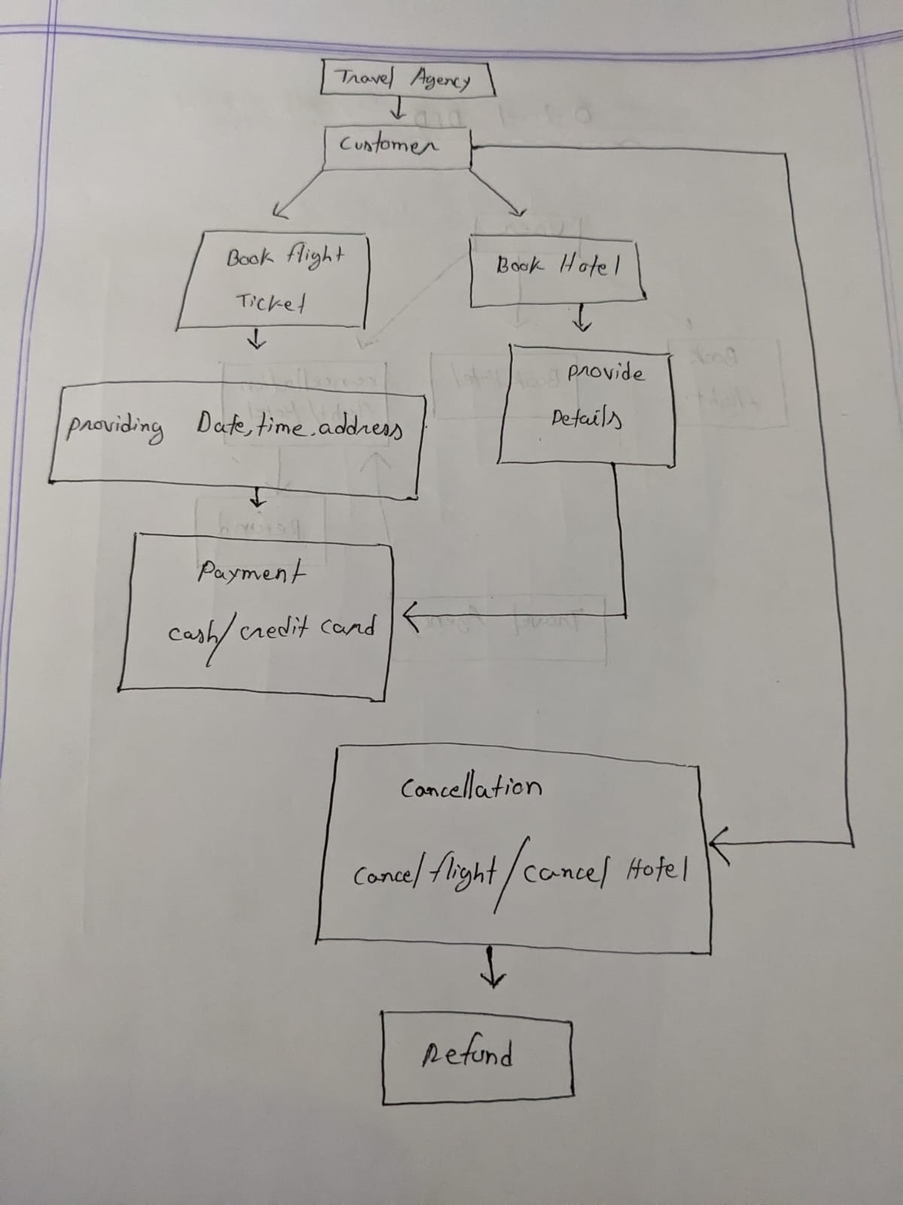

**Q5. Is it possible to visualize the above system that is made by Mr. Babarusing a Data Flow Diagram (DFD)? If Yes then sketch the 0-level and 2-levelDFD, Otherwise explain the reason why it is not possible. [9] [CLO 3]**

**Answer:**

Yes, it is possible to visualize the travel agency system using a Data Flow Diagram (DFD). A DFD is a type of diagram that shows the flow of data through a system. It is a useful tool for identifying the processes, data stores, and external entities in a system.

**0-Level DFD**

The 0-level DFD is the most abstract level of the DFD. It shows the major processes in the system and the data that flows between them. In the case of the travel agency system, the 0-level DFD would look like this:

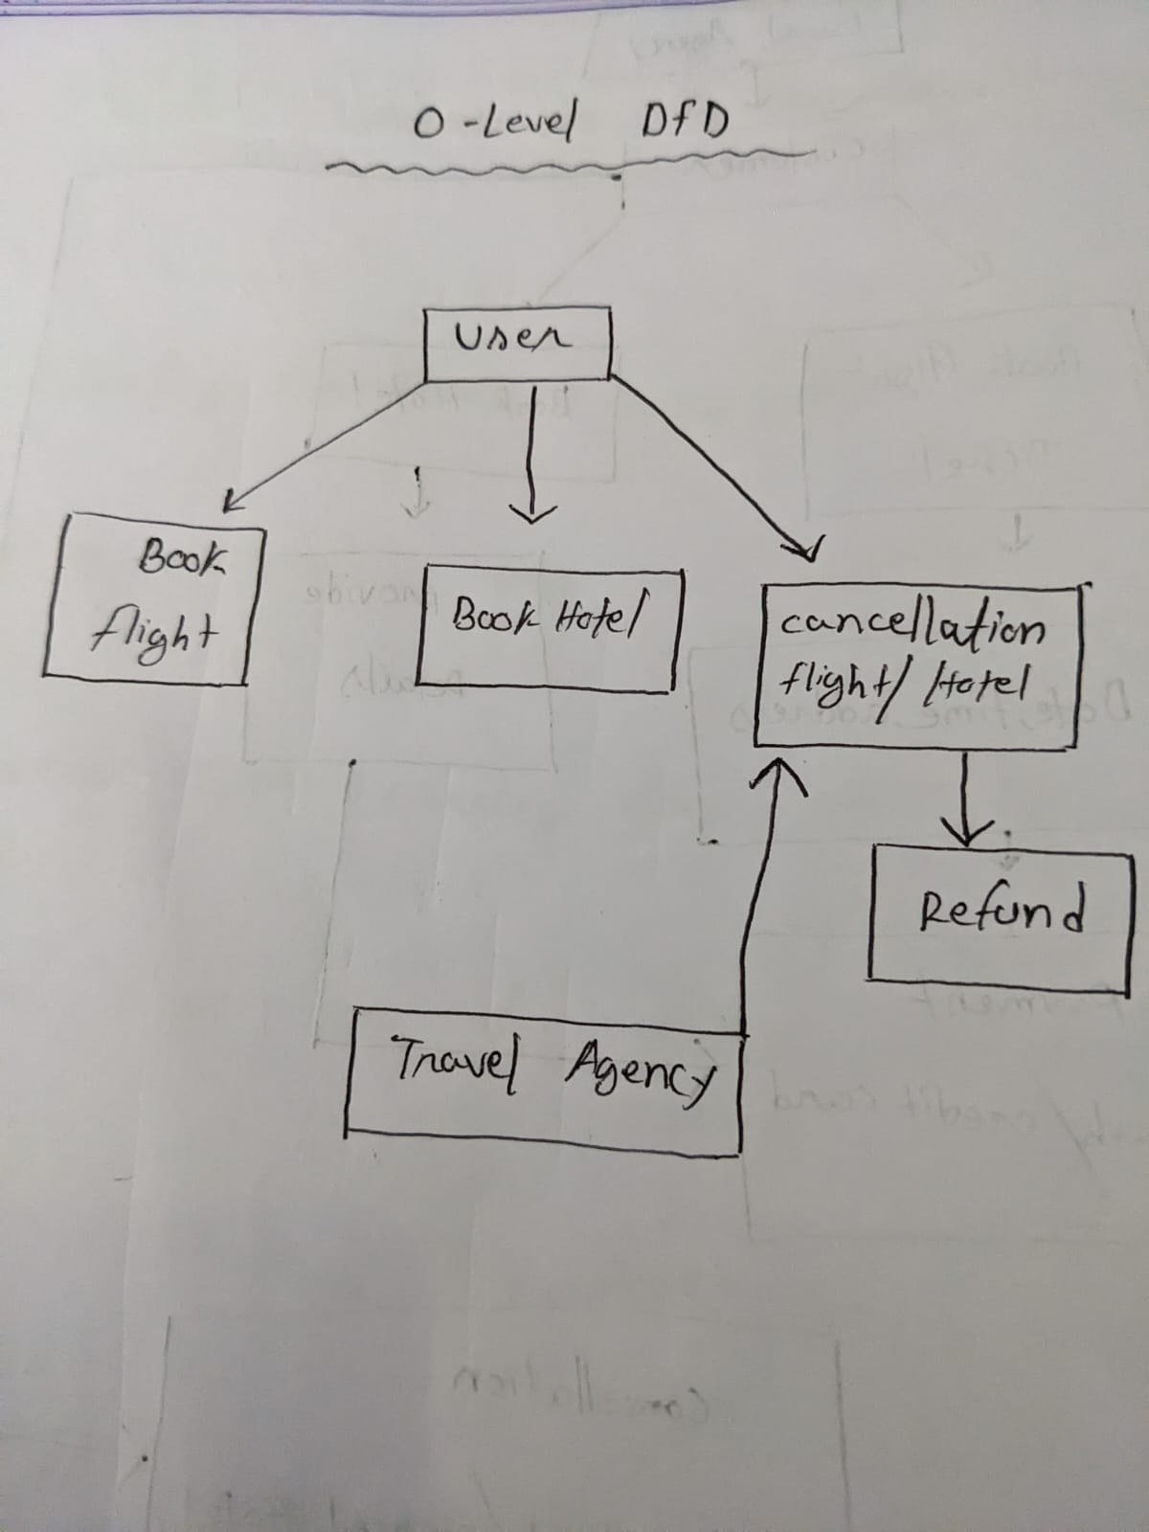

**1-Level DFD**

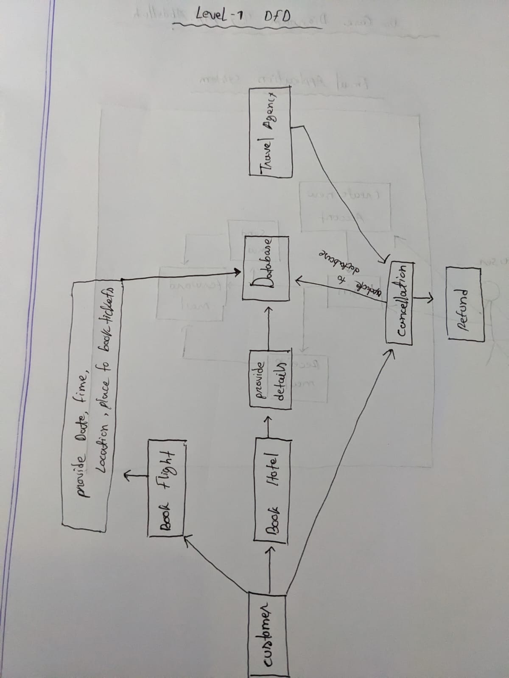

**Conclusion:**

Creating a DFD is possible at a high level, but without more detailed information about internal processes, data stores, and system architecture, the DFD will remain a simplified representation, and creating a comprehensive 2-level DFD may not be feasible based on the available scenario details.

**Q6. Draw the use case diagram that is made by Mr. Abdullah. [4] [CLO-5]**

**Answer:**

Use Case Diagram for Mr. Abdullah's Email Application System:

Actors:

User (Primary Actor)

Use Cases:

Send New Mail:

Description: User can compose and send a new email.

Reply to Email:

Description: User can reply to an email they have received.

Forward Email:

Description: User can forward an email to another recipient.

User Login:

Description: User must log in to perform the above actions

